Nonagonal Prismoid

Definition
# Source: AI Source: Provided by: [Data Path: Persons Table -> ID Column: 1, Name_En Column: Motasem Essam] -> From: [ChatGPT] on [7/25/2026]
A Nonagonal Prismoid is a polyhedron with two parallel nonagonal bases, each having nine sides and nine vertices, connected by nine quadrilateral lateral faces.
The upper and lower nonagonal bases may differ in size, shape, or orientation. The connecting edges must be arranged so that all nine lateral quadrilaterals are planar.
A nonagonal prismoid has 11 faces, 27 edges, and 18 vertices.

Geometric Structure
# Source: AI Source: Provided by: [Data Path: Persons Table -> ID Column: 1, Name_En Column: Motasem Essam] -> From: [ChatGPT] on [7/25/2026]
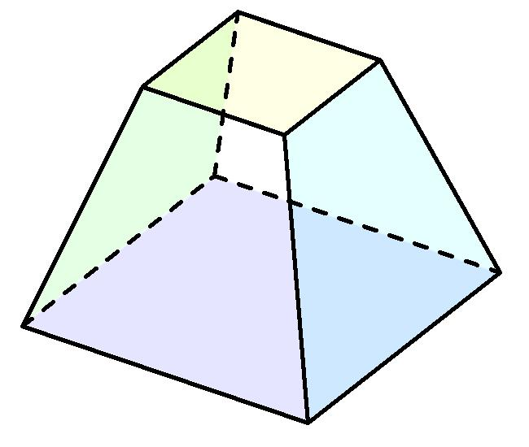
Its main elements are:
- Lower Nonagonal Base: The bottom nine-sided polygon.
- Upper Nonagonal Base: The top nine-sided polygon, parallel to the lower base.
- Lateral Faces: Nine quadrilateral faces connecting corresponding sides of the bases.
- Lateral Edges: Nine edges connecting corresponding vertices of the two bases.
- Vertices: Eighteen vertices in total.
- Altitude: The perpendicular distance between the two base planes.
- Midsection: A cross-section parallel to the bases, halfway between them.

Face Composition
# Source: AI Source: Provided by: [Data Path: Persons Table -> ID Column: 1, Name_En Column: Motasem Essam] -> From: [ChatGPT] on [7/25/2026]
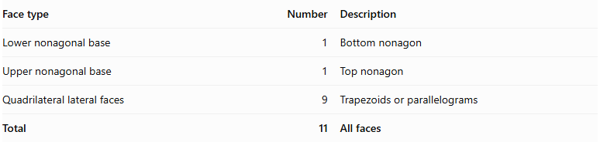
Face type | Number | Description
Lower nonagonal base | 1 | Bottom nonagon
Upper nonagonal base | 1 | Top nonagon
Quadrilateral lateral faces | 9 | Trapezoids or parallelograms
Total | 11 | All faces

Mathematical Properties
# Source: AI Source: Provided by: [Data Path: Persons Table -> ID Column: 1, Name_En Column: Motasem Essam] -> From: [ChatGPT] on [7/25/2026]
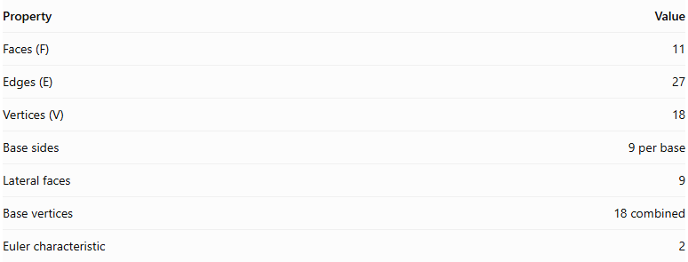
Property | Value
Faces (F) | 11
Edges (E) | 27
Vertices (V) | 18
Base sides | 9 per base
Lateral faces | 9
Base vertices | 18 combined
Euler characteristic | 2
Euler's Formula:
$$V-E+F=2$$
$$18-27+11=2$$
Volume — Prismoidal Formula:
$$V=\frac{h}{6}(A_{1}+4A_{m}+A_{2})$$
Where:
- $A_{1}$ = Area of the lower nonagonal base.
- $A_{2}$ = Area of the upper nonagonal base.
- $A_{m}$ = Area of the midsection parallel to the bases.
- $h$ = Perpendicular distance between the bases.

Area of a Regular Nonagon:
$$A=\frac{9s^{2}}{4tan({20}^{∘})}$$
Where $s$ is the side length of the regular nonagon.

Geometric Characteristics
# Source: AI Source: Provided by: [Data Path: Persons Table -> ID Column: 1, Name_En Column: Motasem Essam] -> From: [ChatGPT] on [7/25/2026]
- It has two parallel nonagonal bases.
- Each base has nine sides and nine vertices.
- It has nine quadrilateral lateral faces.
- Its lateral faces may be trapezoids or parallelograms.
- The two bases do not have to be congruent or similar.
- Its altitude is measured perpendicular to the base planes.
- Its midsection is parallel to both bases.
- It has 18 vertices, 27 edges, and 11 faces.

Types of Nonagonal Prismoids
# Source: AI Source: Provided by: [Data Path: Persons Table -> ID Column: 1, Name_En Column: Motasem Essam] -> From: [ChatGPT] on [7/25/2026]
- Regular Nonagonal Prismoid: Both bases are regular nonagons.
- Irregular Nonagonal Prismoid: At least one base is an irregular nonagon.
- Similar-Bases Nonagonal Prismoid: The two nonagonal bases are similar polygons.
- Non-Similar-Bases Nonagonal Prismoid: The two nonagonal bases are not similar polygons.
These are descriptive subdivisions for classification rather than universally standardized solid names.

Constructing a Nonagonal Prismoid

Geometric Instruments
# Source: AI Source: Provided by: [Data Path: Persons Table -> ID Column: 1, Name_En Column: Motasem Essam] -> From: [ChatGPT] on [7/25/2026]
The following instruments can be used to construct a nonagonal prismoid using traditional geometric drawing methods:
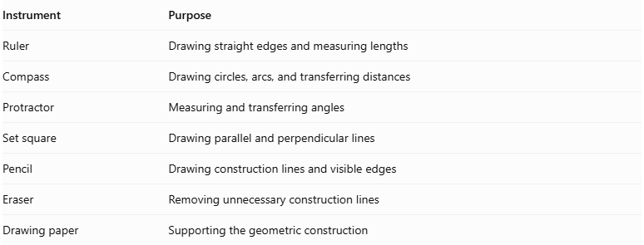
Instrument | Purpose
Ruler | Drawing straight edges and measuring lengths
Compass | Drawing circles, arcs, and transferring distances
Protractor | Measuring and transferring angles
Set square | Drawing parallel and perpendicular lines
Pencil | Drawing construction lines and visible edges
Eraser | Removing unnecessary construction lines
Drawing paper | Supporting the geometric construction
Important note about the regular nonagon: A regular nonagon cannot be constructed exactly using only an unmarked straightedge and compass. Its construction requires an additional instrument or method, such as a protractor or angle trisector. A compass-and-straightedge approximation is also possible.

Instrument-Based Construction Procedures

Method 1: Constructing from Two Parallel Nonagonal Bases
# Source: AI Source: Provided by: [Data Path: Persons Table -> ID Column: 1, Name_En Column: Motasem Essam] -> From: [ChatGPT] on [7/25/2026]
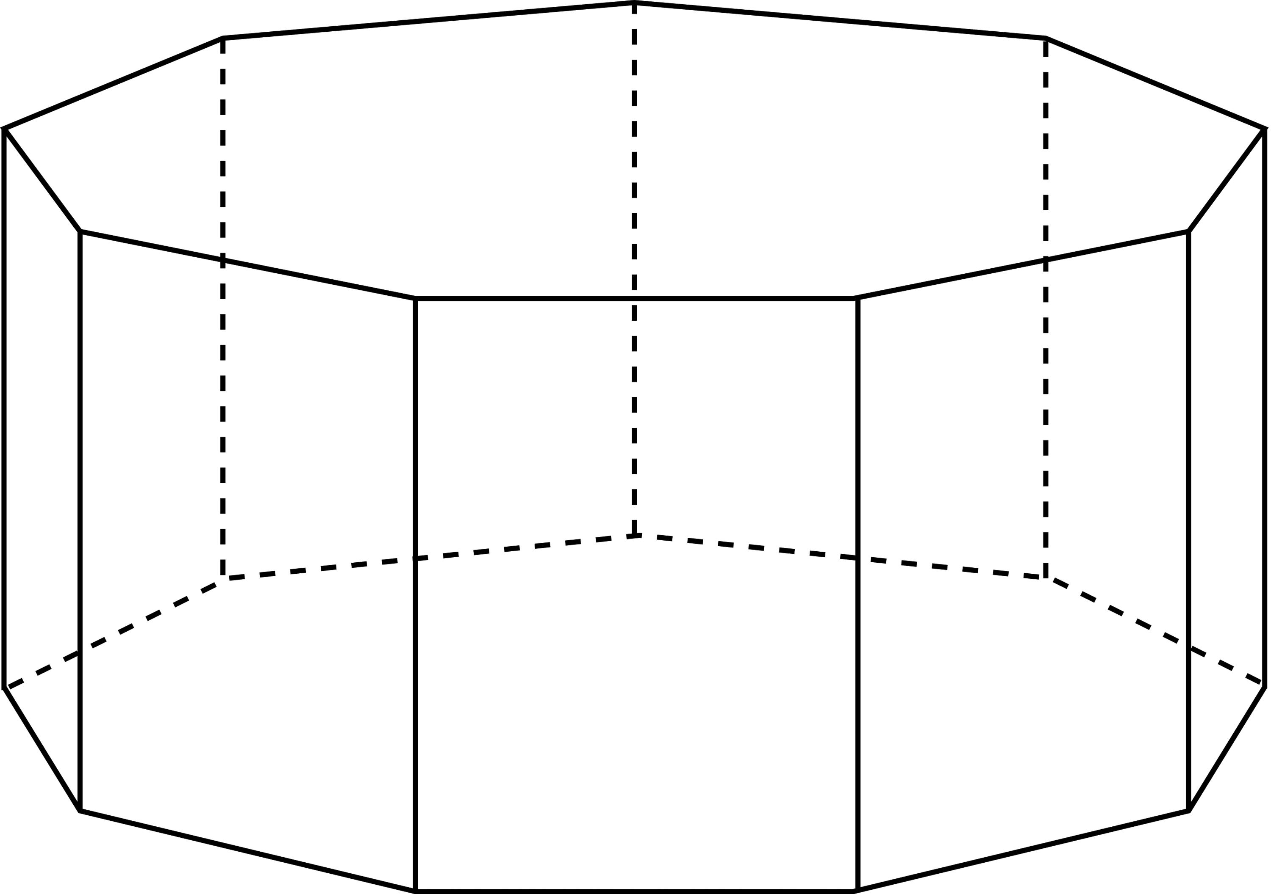
- Draw the lower nonagonal base $ABCDEFGHI$ using a ruler and protractor.
- If constructing a regular nonagon, divide a full circle into nine equal central angles of ${40}^{°}$.
- Establish the required perpendicular height above the lower base.
- Draw the upper nonagonal base $A'B'C'D'E'F'G'H'I'$ in a plane parallel to the lower base.
- Choose the dimensions and positions of the upper nonagon so that the corresponding connecting edges produce planar lateral quadrilaterals.
- Connect $A$ to $A'$.
- Connect $B$ to $B'$.
- Connect $C$ to $C'$.
- Connect $D$ to $D'$.
- Connect $E$ to $E'$.
- Connect $F$ to $F'$.
- Connect $G$ to $G'$.
- Connect $H$ to $H'$.
- Connect $I$ to $I'$.
- Join the corresponding base edges to complete the nine lateral quadrilaterals.
- Erase unnecessary construction lines and distinguish visible edges from hidden edges.

Method 2: Constructing from a Nonagonal Base and Its Parallel Upper Section
# Source: AI Source: Provided by: [Data Path: Persons Table -> ID Column: 1, Name_En Column: Motasem Essam] -> From: [ChatGPT] on [7/25/2026]
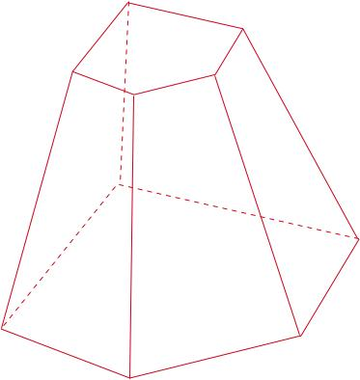
- Construct a nonagon $ABCDEFGHI$ as the lower base.
- Draw a parallel upper construction plane at the required perpendicular height.
- Construct a second nonagon $A'B'C'D'E'F'G'H'I'$ on the upper plane.
- Determine the corresponding positions of the nine upper vertices.
- Check that each pair of corresponding base edges and connecting lateral edges defines a planar quadrilateral.
- Connect the corresponding vertices.
- Complete all nine lateral faces.
- Verify that the upper and lower bases are parallel.
- Finalize the drawing by removing auxiliary lines and marking visible and hidden edges.

Method 3: Constructing Through Parallel Cross-Sections
# Source: AI Source: Provided by: [Data Path: Persons Table -> ID Column: 1, Name_En Column: Motasem Essam] -> From: [ChatGPT] on [7/25/2026]
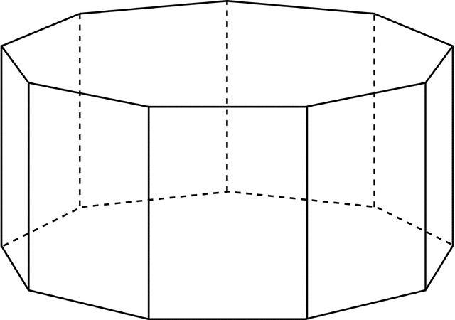
- Draw the lower nonagonal base $ABCDEFGHI$.
- Establish the perpendicular height of the solid.
- Mark the halfway level between the two bases.
- Construct a middle nonagonal cross-section $A_{m}B_{m}C_{m}D_{m}E_{m}F_{m}G_{m}H_{m}I_{m}$, parallel to the bases.
- Construct the upper nonagonal base $A'B'C'D'E'F'G'H'I'$.
- Connect the corresponding vertices of the lower, middle, and upper nonagons.
- Ensure that the resulting lateral faces are planar quadrilaterals.
- Complete the visible and hidden edges.
The middle cross-section is used to calculate the volume using the prismoidal formula.

Related Geometric Solids
# Source: AI Source: Provided by: [Data Path: Persons Table -> ID Column: 1, Name_En Column: Motasem Essam] -> From: [ChatGPT] on [7/25/2026]
- Nonagonal Prism
- Nonagonal Pyramidal Frustum
- Nonagonal Prismatoid
- Octagonal Prismoid
- Decagonal Prismoid

Main Classification
# Source: AI Source: Provided by: [Data Path: Persons Table -> ID Column: 1, Name_En Column: Motasem Essam] -> From: [ChatGPT] on [7/25/2026]
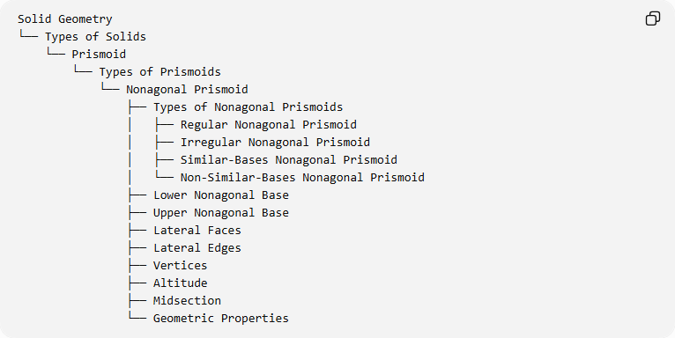
Solid Geometry
└── Types of Solids
└── Prismoid
└── Types of Prismoids
└── Nonagonal Prismoid
├── Types of Nonagonal Prismoids
│ ├── Regular Nonagonal Prismoid
│ ├── Irregular Nonagonal Prismoid
│ ├── Similar-Bases Nonagonal Prismoid
│ └── Non-Similar-Bases Nonagonal Prismoid
├── Lower Nonagonal Base
├── Upper Nonagonal Base
├── Lateral Faces
├── Lateral Edges
├── Vertices
├── Altitude
├── Midsection
└── Geometric Properties

Key Points
# Source: AI Source: Provided by: [Data Path: Persons Table -> ID Column: 1, Name_En Column: Motasem Essam] -> From: [ChatGPT] on [7/25/2026]
- A nonagonal prismoid has two parallel nonagonal bases.
- It contains 11 faces, 27 edges, and 18 vertices.
- It has nine quadrilateral lateral faces.
- Its volume can be calculated using the prismoidal formula.
- It belongs to the family of prismoids.

Conclusion
# Source: AI Source: Provided by: [Data Path: Persons Table -> ID Column: 1, Name_En Column: Motasem Essam] -> From: [ChatGPT] on [7/25/2026]
The Nonagonal Prismoid is a polyhedron formed by two parallel nine-sided bases connected by nine quadrilateral lateral faces. Its structure follows the general properties of prismoids, with 11 faces, 27 edges, and 18 vertices.

